**Challenge Lab - PDE Prep**

Task 1: Create a custom dataset

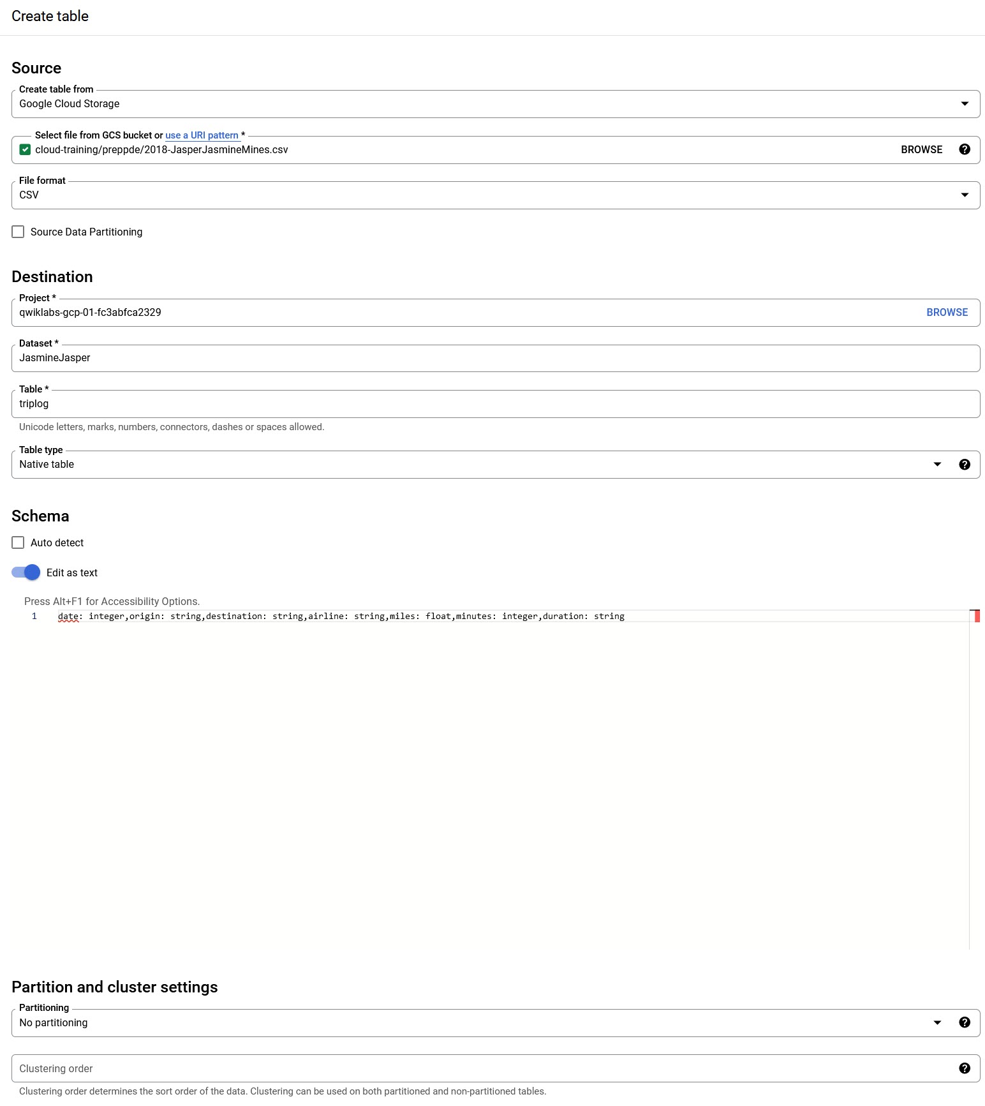

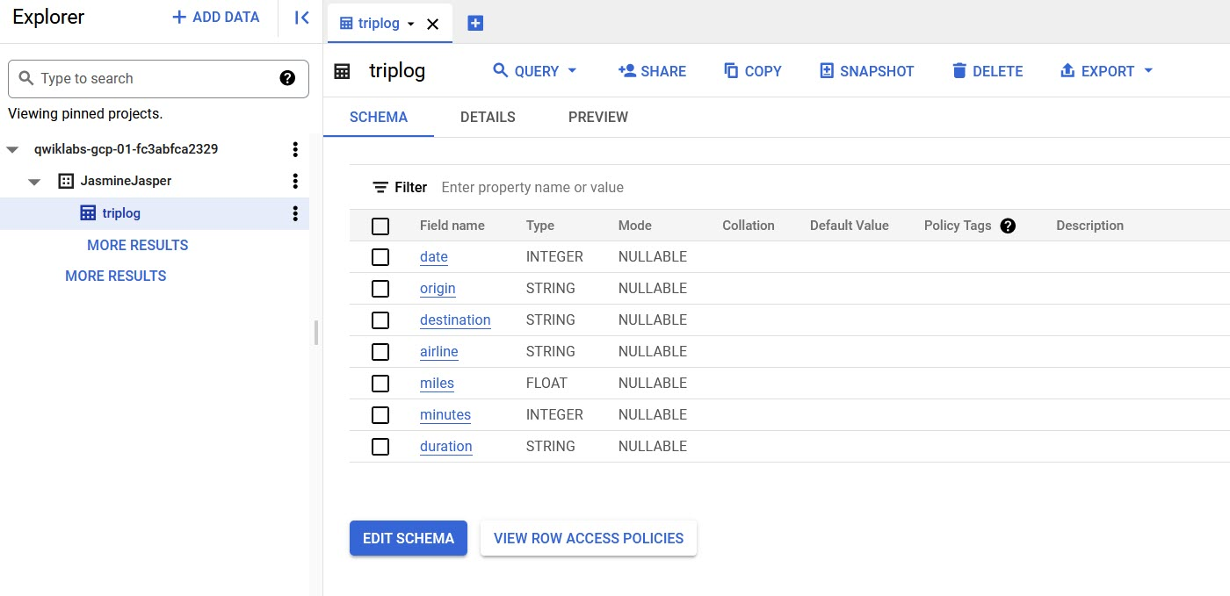

Task 2: Query the dataset

**First Query**

Create a query that produces the average trip time for trips originating from the airport in Frankfurt, Germany (FRA) and destined for the airport in Kuala Lumpur, Malaysia (KUL), and group the results by airline. The resulting average times should be similar.

SELECT airline, AVG(minutes)

FROM JasmineJasper.triplog

WHERE origin = 'FRA' AND destination = 'KUL'

GROUP BY airline

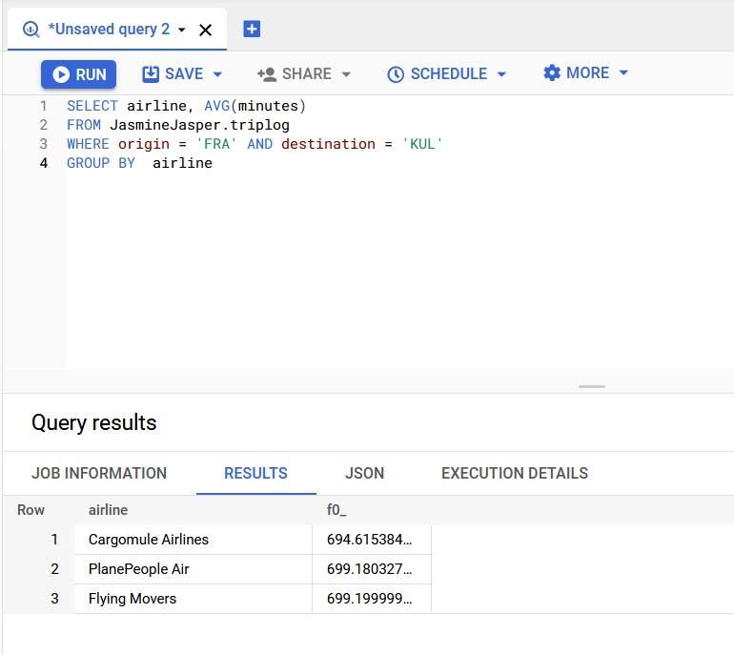

**Second Query**

Create a query that produces the average trip time for trips originating from London Heathrow Airport, United Kingdom (LHR) and destined for the airport in Kuala Lumpur, Malaysia (KUL), and group the results by airline, and order them from lowest to highest. The resulting average times should reveal whether the airline, PlanePeople Air, kept its promise to use faster airplanes from Heathrow Airport.

SELECT airline, AVG(minutes) as avg

FROM JasmineJasper.triplog

WHERE origin="LHR" AND destination="KUL"

GROUP BY airline

ORDER BY avg ASC

